EEG 331 2024/2025 DESIGN PROJECT REPORT

ELECTRONIC CIRCUITS 1 (EEG 331)
DEPARTMENT OF ELECTRICAL AND ELECTRONICS ENGINEERING
UNIVERSITY OF LAGOS, AKOKA.
GROUP 20

PROJECT: DESIGN AND SIMULATION OF SOLAR-POWERED SMART STREET LIGHTING WITH MOTION DETECTION

SUBMITTED TO: DR A. A. AMUSAN

SUBMITTED BY:
1. ERINKITOLA ABDULBAASIT IYANUOLUWA (210408062 - COMPUTER ENGINEERING)
2. EMEKA SAMUEL IFEAYINCHUKWU (210403022 - ELECTRICAL ELECTRONICS ENGINEERING)
3. EZEANOWI CHISOM SHEDRACK (210403103 - ELECTRICAL ELECTRONICS ENGINEERING)
4. EZINMA JOSHUA CHUKWUEMEKA (210403112 - ELECTRICAL ELECTRONICS ENGINEERING)
5. ESEKHAIGBE LORDSON (210407065 - SYSTEMS ENGINEERING)
6. EZERIOHA-ETHELBERT DOMINION KENECHUKWU (230403534 - ELECTRICAL ELECTRONICS ENGINEERING)
7. EYINLE ADEDOLAPO CATHERINE (210403037-ELECTRICAL AND ELECTRONICS ENGINEERING)
8. ETOP-ARCHIBONG EDIDIONG (230407534- SYSTEMS ENGINEERING)
9. EZE DANIEL (210407109 – SYSTEMS ENGINEERING)
10. EZENDIOKWERE CHRISTOPHER (210403504 - ELECTRICAL ELECTRONICS ENGINEERING)

DATE SUBMITTED:
29TH JANUARY, 2025.

INTRODUCTION
Street lighting is a crucial aspect of urban infrastructure, providing numerous benefits to pedestrians, drivers, and the community as a whole. The primary function of street lighting is to illuminate public spaces, ensuring safety, security, and visibility.
Improved safety is a primary advantage, as enhanced visibility reduces accidents and crime. Well-lit areas also deter criminal activity, increasing security for residents and businesses. Furthermore, street lighting has economic benefits, boosting local businesses and property values. Energy-efficient options like LED lighting also reduce carbon emissions, contributing to a more sustainable environment. Solar-powered street lights offer a sustainable solution for urban lighting, one of which is reducing reliance on fossil fuels. Hence, the focus of this project is the solar-powered street lighting system.

AIM OF THE PROJECT
- To calculate the solar panel and battery sizing
- To design and simulate a complete solar power circuit (including solar panel, charge controller, battery, and lighting system) that automatically switches the LED street lights on during dark or low light conditions, incorporating energy-efficient components, such as LEDs and PIR motion sensors, with a switching mechanism (using diodes or transistors).
The goal is to achieve at least a 30% reduction in energy consumption compared to conventional systems without motion detection.

METHODOLOGY
Before the design and simulation of the street lighting system, the required solar panel size, solar charge controller (Maximum power point tracking)/ BMS (Battery Management system) and battery storage capacity to ensure continuous operation of 12V, 20 Watts, street lightening system for a minimum of 12 hours under low sunlight conditions were calculated as follows:
Taking this part of the world as a case study, the number of hours for which street light is needed is less than 12 (worst case scenario is often around 6:30pm – 6:30am i.e. 12 hours). As a result, to minimize cost, whilst efficiency in performance is still assured, we shall work with 12 hours in our design, even though that is the minimum requirement.
Hence, we shall work with:
- Battery of 12 V, 20 W capacity
- Street lightening system with a 12-hour duration capacity

CALCULATION OF THE COMPONENTS’ SIZING
- Battery Sizing
We need a 12V, 20W battery capable of running for 12 hours. This implies that the battery should be a 240 (i.e. 20*12) watt-hour battery. This is equivalent to a 20000mAh (i.e. 240watt-hour/12000mV) battery.
However, we shall work with a 30000mAh battery due to the consideration of periods of low sunlight. This allows the battery to store more energy in peak sunlight conditions, thereby allowing it to last longer during periods of low sunlight. With this, we have also successfully accounted for possible low efficiency of the LEDs we shall use. Additionally, when fully charged, the battery is able to last 18 hours (i.e. (30000mAh * 12V)/20W) in rare or unexpected occasions like lunar eclipse. This 30000mAh battery is equivalent to a 360 (i.e. 20W * 18 hours) watt-hour battery. This will efficiently power a 20W LED for a minimum of 12 hours and maximum of 18 hours, as the energy consumption of the 20W LED is 240Wh (for 12 hours) and 360Wh (for 18 hours).
Hence, the street light can run for a minimum of 12 hours and a maximum of 18 hours.
However, we have one more thing to consider, which is the depth of discharge of the battery we are using. Li-ion batteries are in better position to use due to their long lifespan, higher energy efficiency, lightweight design, and minimal maintenance needs. The depth of discharge of Li-ion batteries is approximately 80% compared to that of Lead acid batteries (50%). Considering this, we go for a Lithium-ion battery of 450Wh (360Wh/80%) or 37500mAh (30000mAh/80%) capacity, or one with a closer capacity.

- Solar Panel Sizing
Solar panel sizing is how much energy the solar panels will optimally produce in an hour of direct sunlight with perfect conditions. It is calculated as Energy required / Peak sunlight hours
Subsequently, for this operation, we need a solar panel that can power our 37500mAh (450Wh) battery efficiently, while assuming the number of peak sunlight hours as 5 hours, and a safety factor of 1.2 to account for inefficiencies and low sunlight conditions. As such, the energy required is estimated as 450Wh * 1.2 = 540Wh.
Hence, the solar panel sizing to be used is 108W (i.e. 540Wh / 5 hours).
Considering dirt, shading, wiring inefficiencies, etc., we assume a 75% efficiency for the solar panel. Hence, we go for a solar panel of 144W (i.e. 108W/75%) capacity. This means we will go for a 144W (or the nearest round figure available in the market e.g. 150W) solar panel to ensure the street light run for a minimum of 12 hours.
It can be noticed that the 15-25% output efficiency of solar panels is not factored in here. This is because that has already been factored in by the manufacturer when labeling the wattages of solar panels.

- Charge Controller (MPPT) Sizing
For the 150W solar panel supplying the 12V battery, we need a charge controller to maximize its output. For its specifications, we take into account a safety factor of 1.2 to account for temperature, shading, or other variations. Hence, we need a 12.5A [i.e. (150W/12V) * 1.2] MPPT charge controller.

- LED
Using a Q Watt (i.e. 20W) LED, we need to add a current-limiting resistor to the circuitry to prevent the LED from damaging. From this, we can calculate the current passing through the resistor and LED while it is ON.
Power = Current * Voltage
- Current = Power/Voltage
= 20/12
=1.667A

SUMMARY OF REQUIRED COMPONENTS
- 150W Solar Panel
- 12.5A MPPT Charge controller.
- 37.5Ah, 12V lithium-ion battery
- 20W LED

SYSTEM OVERVIEW
The street light operates using a 150W solar panel and a 12V, 37.5Ah Li-ion battery. The LED turns ON or OFF accordingly based on the output of the Voltage-Controlled Voltage Source (VCVS). The VCVS outputs 0V (when the AND-Gate outputs 0V) and 5V (when the AND-Gate outputs 1V). It receives input from the AND-Gate which only outputs 1V when both darkness and motion are detected. The VCVS output in turn controls the MOSFET acting as an electronic switch for the LED.

COMPONENTS USED IN THE LTSPICE DESIGN AND SIMULATION
1. Solar Panel and MPPT (Maximum Power Point Tracking):
- V1 (18V source): Represents the solar panel. The panel provides energy during the day. In this design, an 18V voltage source is chosen to represent the solar panel so as to power the 12V battery sufficiently.
- D1 (Schottky diode): Prevents reverse current flow from the battery back to the solar panel, improving efficiency.
- C1 (100 μF capacitor): Smoothens voltage fluctuations from the solar panel.
- Inductor (L1): It is used in conjunction with a PWM signal (Vpwm) and the switching MOSFET (M1) to regulate the voltage and current from the solar panel, ensuring that the panel operates at its maximum power point under varying sunlight conditions. It also temporarily stores energy and helps smooth the current supplied to the battery.
- Vpwm (Pulse Width Modulation Signal Generator): It turns the MOSFET on and off at a specific frequency and duty cycle, controlling how much energy is passed to the battery. By rapidly switching the MOSFET on and off, the PWM adjusts the effective load on the solar panel to maintain operation at its maximum power point (where it delivers the most efficient combination of voltage and current).
- M1 (Switching NMOS Transistor): This is the switching element in the MPPT circuit. It allows high-efficiency switching with minimal power loss.
  - When Vpwm turns M1 on, current flows through the inductor (L1), storing energy.
  - When M1 turns off, the inductor releases its stored energy to the battery.
- MPPT Circuit: Simulated here manually to maximize the power extracted from the solar panel under varying light conditions.
Optimization: The MPPT ensures the solar panel operates at its peak efficiency to charge the battery.

2. Battery Management System (BMS):
- Battery (14.8V Li-ion): Stores energy from the solar panel. This is a 4-cell Li-ion battery configuration (each cell = 3.7V nominal).
- V2 (14.8V supply): Represents the battery after charging. The BMS protects the battery from overcharging and deep discharge.
Optimization:
- The BMS ensures the battery operates safely and at optimal efficiency, extending its lifespan.
- Li-ion batteries offer higher energy density, longer lifespan, greater efficiency, faster charging, deeper discharge capability, better temperature performance, lower self-discharge, and lower lifetime costs compared to lead-acid batteries.

3. Voltage Regulators:
- LT1083-12 (12V regulator): Regulates the battery voltage to the specified 12V in the question to drive the LED and other components.
- LT1085-5 (5V regulator): Steps down the voltage to 5V to power the motion and light detectors, comparators, and logic gates.
Optimization: These regulators provide stable voltages for the various subsystems, ensuring consistent operation.

4. LED Driver Circuit:
- LED (20W high-power LED): The primary light source for the street light.
- R_lim (4.57Ω): This is a current-limiting resistor. It ensures the LED receives the correct operating current to avoid damage. The 4.57Ω can alternatively be derived by connecting a 53Ω resistor in parallel with a 5Ω resistor.
- N-MOSFET(Si4816BDY): Acts as a switch to turn the LED on/off. It is controlled by the AND gate output.
Optimization: Proper current limiting and switching ensure efficient LED operation with minimal power loss.

5. Light Detector Circuit:
- LDR (Light-Dependent Resistor): Detects ambient light levels. Its resistance decreases with increasing light intensity.
- Comparator1 (LT1017): Compares the voltage from the light detector to a reference voltage (V_ref) to determine whether it is dark.
  - If dark, the comparator outputs a HIGH signal (logic 1) to the AND gate.
  - If not dark, the comparator outputs a LOW signal (logic 0) to the AND gate.
- R5 (1kΩ): This is a pull-up resistor connected between the comparator output and the supply voltage to ensure the output reaches the 5V HIGH voltage.
Optimization: The comparator ensures the LED operates only at night, conserving energy during the day.

6. Motion Detector Circuit:
- PIR Sensor (Vpir): Outputs a pulse signal when motion is detected.
- Comparator2 (LT1017): Amplifies and converts the PIR sensor signal into a HIGH or LOW logic level.
  - If motion is detected, the comparator outputs a HIGH signal (logic 1) to the AND gate.
  - If no motion is detected, the comparator outputs a LOW signal (logic 0) to the AND gate.
- R3 (1kΩ): This is a pull-up resistor connected between the comparator output and the supply voltage to ensure the output reaches the 5V HIGH voltage.
Optimization: The motion detector activates the LED only when motion is detected, reducing unnecessary power consumption.

7. Logic Control (AND Gate) and VCVS (Voltage-Controlled Voltage Source):
  - AND Gate: Combines the outputs of the light detector and motion detector. The LED turns on only when it is dark (light detector output = HIGH) and motion is detected (motion detector output = HIGH).
  - VCVS: The AND-Gate in Ltspice only gives 0V or 1V as outputs. To maintain the 0V for LOW and 5V for HIGH as the output from the comparators, the VCVS is introduced. To obtain this result, the output from the VCVS is set to be 5 times the output from the AND-Gate.
Optimization: By combining both light and motion detection, the system minimizes energy usage by turning on the LED only when needed.

8. NMOS Switching Circuit:
- N-MOSFET(Si4816BDY): Acts as a power switch for the LED. When the AND gate outputs a HIGH signal, M2 is turned on, completing the LED circuit and allowing current to flow.
Optimization: The use of an NMOS transistor ensures efficient switching with low losses.

9. Grounds: The grounds in the circuit serve as the common reference point for all voltages. They ensure proper signal and power flow throughout the circuit.

SUMMARY OF THE DESIGN OPTIMIZATION FEATURES
- Balance Between Sensitivity and Energy Efficiency:
- Combining light and motion detection ensures the LED is used only when necessary.
- The use of 3.5V comparator reference voltage ensures timely activation in low-light conditions, supporting safety, and avoids premature triggering during conditions when it’s not quite dark and maximizes battery life for a reliable streetlight application.
- Battery Protection: The BMS prevents overcharging/discharging, preserving battery life.
- Current Limiting: The resistor (R_lim) protects the LED from excessive current.
- Stable Operation: Voltage regulators provide stable power to the LED and control circuits, even under fluctuating battery voltage.
- Simplified Control: The AND gate ensures simple and reliable logic for controlling the LED.

SYSTEM OPERATION
- Inactive State:
    - When there is no darkness and no motion is detected: The LDR outputs less than the comparator’s 3.5V reference voltage, and the PIR sensor outputs 0V. As a result, the LDR comparator outputs a low voltage close to 0V while the PIR comparator also outputs close to 0V. As such, the AND-Gate outputs 0V, and the VCVS connected to the gate consequently outputs 0V, keeping the MOSFET OFF. Hence, the LED remains OFF.
    - When there is no darkness but motion is detected: The LDR outputs less than the comparator’s 3.5V reference voltage, and the PIR sensor outputs 5V. As a result, the LDR comparator outputs a low voltage close to 0V while the PIR comparator outputs close to 5V. As such, the AND-Gate outputs 0V, and the VCVS connected to the gate consequently outputs 0V, keeping the MOSFET OFF. Hence, the LED remains OFF.
    - When there is darkness but no motion is detected: The LDR output is greater than the comparator’s 3.5V reference voltage, and the PIR sensor outputs 0V. As a result, the LDR comparator outputs a voltage close to 5V while the PIR comparator outputs close to 0V. As such, the AND-Gate outputs 0V, and the VCVS connected to the gate consequently outputs 0V, keeping the MOSFET OFF. Hence, the LED remains OFF.

- Active State:
    - When there is both darkness and motion: The LDR output is greater than the comparator’s 3.5V reference voltage, and the PIR sensor outputs 5V. As a result, the LDR comparator outputs a voltage close to 5V while the PIR comparator also outputs close to 5V. As such, the AND-Gate outputs 1V, and the VCVS connected to the gate consequently outputs 5V, turning the MOSFET ON. Hence, the LED turns ON.

EXPERIMENT RESULTS
Case 1: When there is darkness (R_ldr = 100kilo-ohms) and there is motion (Vpir = V(n015) = 5V), I_led = 1.667A (LED turns on).
This can be deduced in the transient analysis when time t = 0-1s, 2s-3s, …
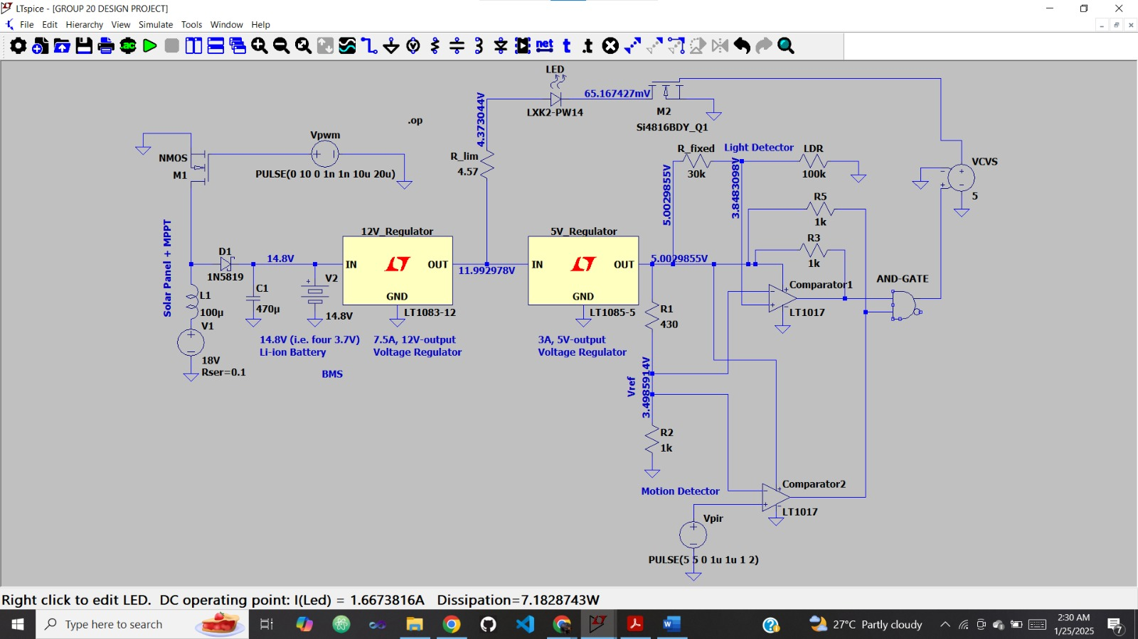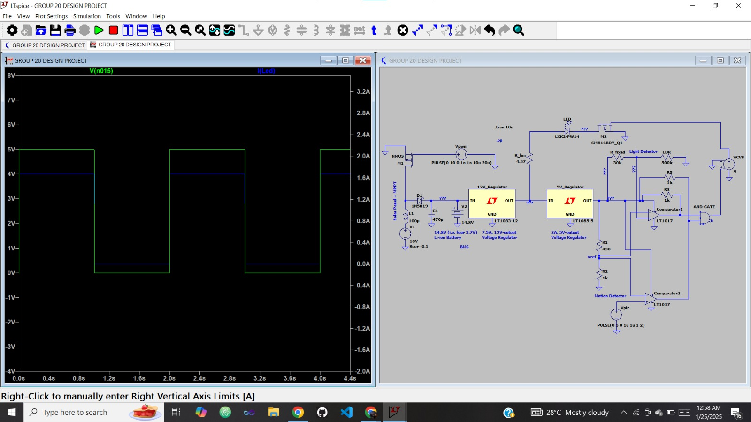

Case 2: When there is no darkness (R_ldr = 10kilo-ohms) and there is motion (Vpir = V(n015) = 5V), I_led = 0 (LED is off).
This can be deduced in the transient analysis when time t = 0-1s, 2s-3s, … However, at 1s, 2s, … the current is apparently not just 0A. This is due to the pulse width modulation signal generator used in the MPPT design. The PWM signal generator produces transient currents due to switching effects in the pulse voltage used simulating motion detection.
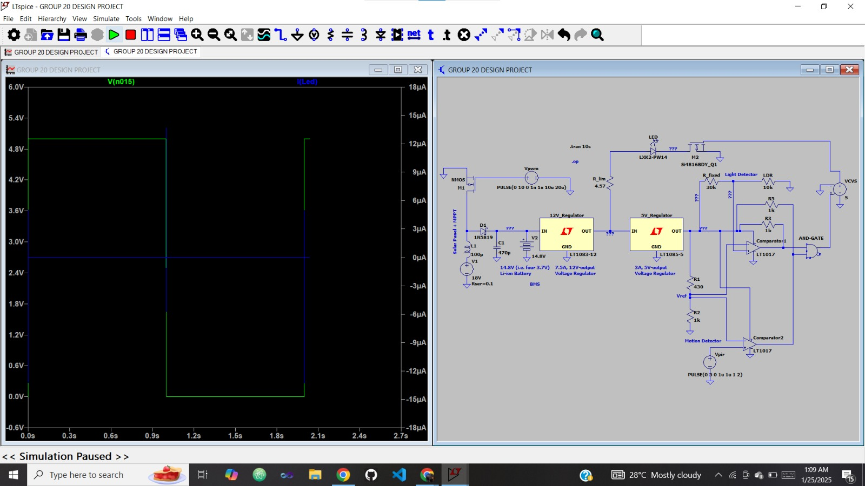

Case 3: When there is darkness (R_ldr = 100kilo-ohms) and there is no motion (Vpir = V(n015) = 0), I_led = 0 (LED is off).
This can be deduced in the transient analysis when time t = 1s-2s, 3s-4s, …

Case 4: When there is no darkness (R_ldr = 10kilo-ohms) and there is no motion (Vpir = V(n015) = 0), I_led = 0 (LED is off).
This can be deduced in the transient analysis when time t = 1s-2s, 3s-4s, … Though, at 1s, 2s, …, as stated in Case 2, the current is apparently not just 0A. This is due to the pulse width modulation signal generator used in the MPPT design. The PWM signal generator produces transient currents due to switching effects in the pulse voltage used simulating motion detection.

PRICES OF MATERIALS TO BE USED IN IMPLEMENTATION
- 18V Solar Panel - #25000
- Four 3.7V Li-ion Batteries - #12000
- LED - #200
- 7 Resistors - #21000
- PIR Motion Sensor - #300
- Charge Controller - #15000
- Board - #5000
- MOSFET - #2000
- Capacitor - #500
- Inductor - #500
- 2 Voltage Regulators - #20000
- Connecting Wires - #1000
- Casing, Stand, etc - #15000
TOTAL - #120000

CHALLENGES
- MPPT Optimization: Using a manually controlled MPPT system instead of a dedicated MPPT controller IC instead of a simplified circuit to maximize energy harvesting from the solar panel was a major challenge since Ltspice does not have a readily available component for that.
- Component Selection: Choosing appropriate components, such as the solar panel, battery, LED, comparators, and regulators, to meet the design specifications.
- Circuit Complexity: Managing the integration of various subsystems like MPPT, battery charging, motion detection, and LED control into a single cohesive design.
- Debugging Errors: Identifying and fixing errors in the comparator circuit, simulation, incorrect component values, or improper wiring.
- Simulation Accuracy: Ensuring the LTspice simulation accurately represents real-world conditions.

LESSONS LEARNT
- System Integration: Combining multiple subsystems, such as motion detection, light sensing, power regulation, and LED control, requires careful planning and design
- Power Management: Efficient energy management is crucial, especially in solar-powered systems where energy availability is limited and variable.
- Debugging Skills: Troubleshooting issues like incorrect gate outputs or unexpected LED behavior builds problem-solving skills and helps understand circuit theory better.
- Environmental Considerations: Accounting for real-world factors such as temperature, dust, and humidity is important when designing reliable outdoor systems.
- Optimization Matters: Small changes in component values or circuit configurations can lead to significant improvements in efficiency and performance. Also, balancing cost, complexity, and performance is very important in other to get the most out of your project.
- Teamwork and Communication: Collaborating with team members enhances problem-solving and idea generation. Ensuring clear communication is also very important
- Iterative Design: Continuous testing, analyzing, and improving are key steps toward achieving the desired functionality.
- Documentation is Key: Keeping detailed records of design choices, calculations, and simulation results is important for troubleshooting and future projects.

POTENTIAL IMPROVEMENTS
- Energy Storage Backup: By integrating a secondary backup battery or supercapacitor to ensure reliable operation during extended low-light conditions.
- Monitoring System: By utilizing an IoT module for remote monitoring of power generation, battery status, and energy usage.
- Thermal Management: By improving the heat dissipation of the LED and regulators with heat sinks or active cooling if needed.
- Accuracy in Motion Sensing: By calibrating the PIR sensor to avoid false triggers due to environmental noise or movement from non-human sources.

DEDUCTIONS
Since we have confirmed the correctness of our design, we can also tell that we have achieved our main goal which is to achieve at least a 30% reduction in energy consumption compared to conventional systems without motion detection. The ratio of night commuters to daylight commuters even in demanding times is less than 1:2.
Taking 12 hours of daylight and 12 hours of night time for instance; without motion detection, the streetlight system will work throughout the night for 12 hours, while with the integration of motion detection into the system, the streetlight works for about 6-7 hours per night. This means that in our design where the use of motion detection is leveraged on, we were able to achieve the goal of a minimum of 30% reduction in energy consumption compared to conventional systems without motion detection.
In addition, we have been able to verify that our design is correct, owing to the fact that the efficiency of an LED is typically around 30-40%. For our design, as shown at the bottom left of the image attached to case 1 in the experiment results, the power being dissipated by the LED is 7.18W, whereas, the LED is a 20W LED. This means that despite consuming 20W power, the LED is only able to give out 7.18W which is 36% of the power consumed. This conforms with the 30-40% efficiency range expected of LEDs.

CONCLUSION
With this project, we are able to implement a system that combines PIR (Passive Infrared) sensor and LDR (Light-Dependent Resistor) to power a solar street light based on both the ambient light levels and detected motion. This integration allows for a control mechanism where the street light responds dynamically to changes in both lighting conditions and the presence of motion. The combined operation of these sensors not only enhances the efficiency of the lighting system but also showcases a practical application of sensor technology for responsive, adaptive illumination, and energy-saving capacity.
Most importantly, with this design and simulation, we have achieved our goal of a minimum of 30% reduction in energy consumption compared to conventional systems without motion detection.

REFERENCES
- https://www.sciencedirect.com/science/article/pii/S2214367X24000139
- https://www.analog.com/media/en/technical-documentation/data-sheets/108345fh.pdf
- https://www.researchgate.net/publication/341525025_CALCULATION_OF_THE_SOLAR_ENERGY_SYSTEM
- https://www.eleccircuit.com/the-most-lead-acid-battery-charger-circuit-by-lm317/
- https://www.youtube.com/playlist?list=PLT84nve2j1g_wgGcm0Bv3K4RSl2Jdjsey
- https://www.youtube.com/playlist?list=PLGtyXSn57qnKRiIqfpVK3ZtzOD8eb_2ro
- Microelectronics Circuits - 7th edition by Sedra and Smith.pdf

